12. Craters and surface ages

Goals
- Evaluate the hypothesis that the entire surface of the Moon has been exposed to impacts for the same amount of time.
- Use images of the moon taken from the Lunar Reconnaissance Orbiter (LRO) to count large craters in both the dark and light regions of the Moon
- Examine data from rock samples collected during Apollo missions to examine the relationship between cratering and surface age.

Resources
Part 1:Use Color enhanced image of moon to examine craters on Moon
http://www.nasa.gov/images/content/482253main_v_01_james_head_1280.jpg

Part 2: Lunar and Planetary Institute: Lunar Rock Samples
http://www.lpi.usra.edu/lunar/samples/

Background Knowledge
Craters we see on the surfaces of objects like the moon are essentially holes left in the ground from the impact of an object colliding with the surface. These impacts are usually so powerful that the crater in the ground can easily be more than ten times wider than the impacting object itself. After the collision, the impactor's mass becomes part of the larger object and there is one less thing floating around space that could hit the larger object. During the formation of the moon, it is expected that large impacts would have occurred at random locations over its entire surface as it swept up smaller objects. As these objects were swept up by the moon, the number of objects that remained to collide with was reduced, and thus, the amount of crater formation declined over time to extremely low values.

Part 1: Craters on the surface

Consider the following hypothesis: The surface we now see on the moon has all been exposed to impacts for the same amount of time.

Think about it
To evaluate this hypothesis, begin by examining the picture of the moon taken from the LRO which has color enhancements on larger sized craters. Look at how the craters vary in size and location. Are the craters evenly distributed across the surface? Do the craters have a uniform size? Why might there be different sizes of crater? Why might there be a non-uniform coverage of craters across the surface?

Work on it
Begin by measuring the size of the image on the page in units of millimeters. Then use the actual size of the moon, about 3,400km, to find the scale of the picture in km/mm. e.g. If the image were 100 mm across then the scale would be: scale = 3,400km/100mm = 34km/mm. Thus, every millimeter of distance on the image would correspond to 34 kilometers of distance on the Moon.
Find the number of large craters visible on the image of the moon. Consider a large crater to be about 70km across or larger. Use your scale and a ruler to estimate how many craters of this size can be seen on the moon. Keep track of how many are in the darker Maria regions and how many are in the light Highlands regions. Make sure to record your data.

Think about it
The darker Maria regions of the moon make up about 20% of the surface area of the whole moon. How many craters would you expect to find in the Maria regions from these large impacts? What conclusion can you draw about the time when the Maria regions formed as compared the time the large impacts occurred? Does it support or refute the hypothesis stated at the beginning of this section? Draw your own conclusion about the relative ages of the Maria and Highlands regions.

Part 2: Ages of Lunar rocks

Think about it
The rocks from the lunar Maria tend to be made from volcanic basalts. The rocks from the lunar highlands tend to be igneous or plutonic rocks like feldspars (anorthosite and plagioclase), zircons, and KREEP. Breccia rocks are formed from many small chunks of other rocks that have been fused together, and they can be found in both highland and Maria regions.

At the end of this lab is a table of data for lunar rocks taken from several locations on the Moon during the Apollo missions. Order the data from youngest to oldest. Roughly how many different groups can you find based on rocks with similar ages, and what is the average age of rocks belonging to each of those groups?

Work on it
Record the data for rock type and age for at least 5 rock samples from highland regions and 5 from the Maria regions. Go to the LPI website below to find records of a large number of lunar rock samples.

http://www.lpi.usra.edu/lunar/samples/
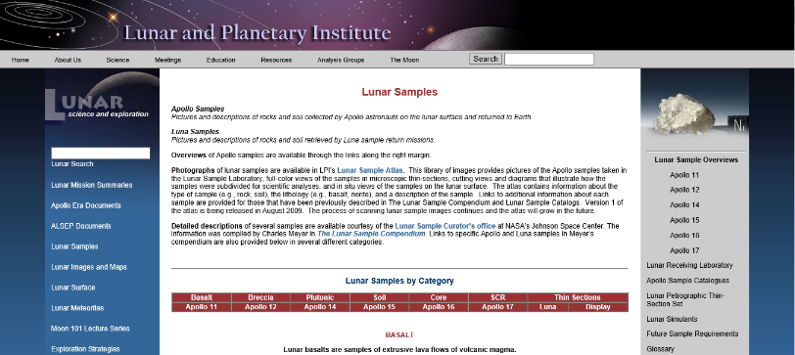
The Apollo 11 mission landed in a large Maria region, Apollo 16 landed in a large highland region, and the other Apollo missions were close to the boundaries of Maria and highland regions. Use the mission number and type of rock as a guide to the region it was found. Note that age data is not reported for all rocks, so you may need to look at data for several rocks. Include the mission, the rock sample number, rock type, and age data in your report.
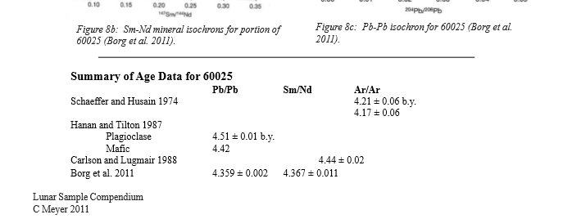
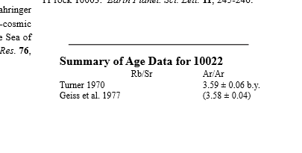
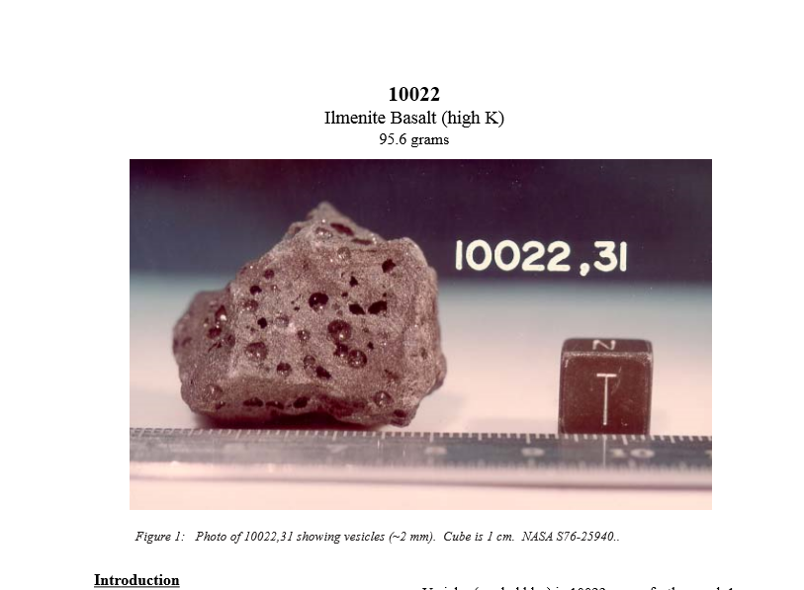
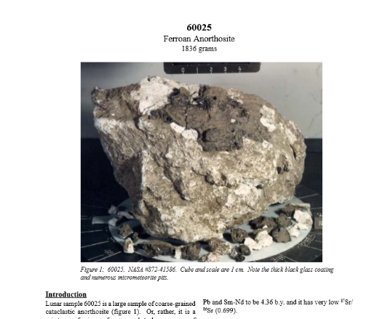

For example:
Highlands: Apollo 16 #60025, Ferroan Anorthosite, 4.35 billion year age (average of 7 estimates).
Maria: Apollo 11 #10022, Ilmenite Basalt, 3.59 billion year age (average of 2 estimates)

Work on it
Combine your data with the data in the table at the end of the lab to compute the average age of the lunar Maria regions and the average age of the mountain highland regions.

Think about it
Considering your conclusion from the first part to be your hypothesis for this part. Do your results here support or refute that hypothesis? How would the results here generalize to other objects in the solar system?

Lab Report Requirements

Introduction: Summarize the goals of the lab and the connection between impact craters and surface age.
Part 1: Cratering.
State the hypothesis you are testing.
Describe the method you used to test it
Show your results
Evaluate the hypothesis to draw your own conclusion.
Part 2: Lunar rock ages
Use your conclusion to the first part as your hypothesis for the second part
Describe the method you used to evaluate the hypothesis
Show the results from the rock ages you looked up
Combine your data with the data in the lab’s table to compute the average age of Maria rocks
and Highland rocks
Evaluate you second hypothesis based on your combined data.
Conclusion: Conclude with a discussion of your results and how they could generalize to other
objects in the solar system.

Table 1. Lunar Rock Data

Location | Mission | Rock Type | Age (Billion years)
Mare Tranquillitatis | Apollo-11 | Basalt | 3.50
Oceanus Procellarum (Mare region) | Apollo-12 | Basalt | 3.20
Fra Mauro Highlands | Apollo-14 | Basalt | 4.15
 | Apollo-14 | Impact melt breccia | 3.85
 | Apollo-14 | KREEP | 4.42
Mare Imbrium | Apollo-15 | Basalt | 3.25
 | Apollo-15 | Anorthosite | 4.09
Descartes Mountains | Apollo-16 | Breccia | 3.98
 | Apollo-16 | Basalt | 3.79
 | Apollo-16 | Anorthosite | 4.47
 | Apollo-16 | Plagioclase | 4.56
 | Apollo-16 | Plagioclase | 4.29

[adapted from spacemath.gsfc.nasa.gov]

